Git

* Version Control System

Other VCS Tools

* Git
* Subversion
* Microsoft VSS
* Microsoft TFS
* IBM Accurev
* CVS
* Mercural

Terminologies

* Local Repository
* Remote Repository
* Promote/Add/Commit/Push – Whenever you are making changes to your local repository , you will add those changes to remote Repository
* Commit ID
* Update/Pull – Getting the latest changes from Remote Repository to Local repository
* Version Control is the management of changes to documents, computer programs, large websites and other collection of information.
* There are two types of VCS:
  + Centralized Version Control System (CVCS)
  + Distributed Version Control System (DVCS)
* Repository – A directory or storage space where your projects can live. It can be local to a folder on your computer, or it can be a storage space on GitHub or another online host. You can keep code files, text files, image files, you name it, inside a repository.

**Centralized Version Control System**

* Uses a central server to store all files and enables team collaboration. It works on a single repository to which users can directly access a central server.

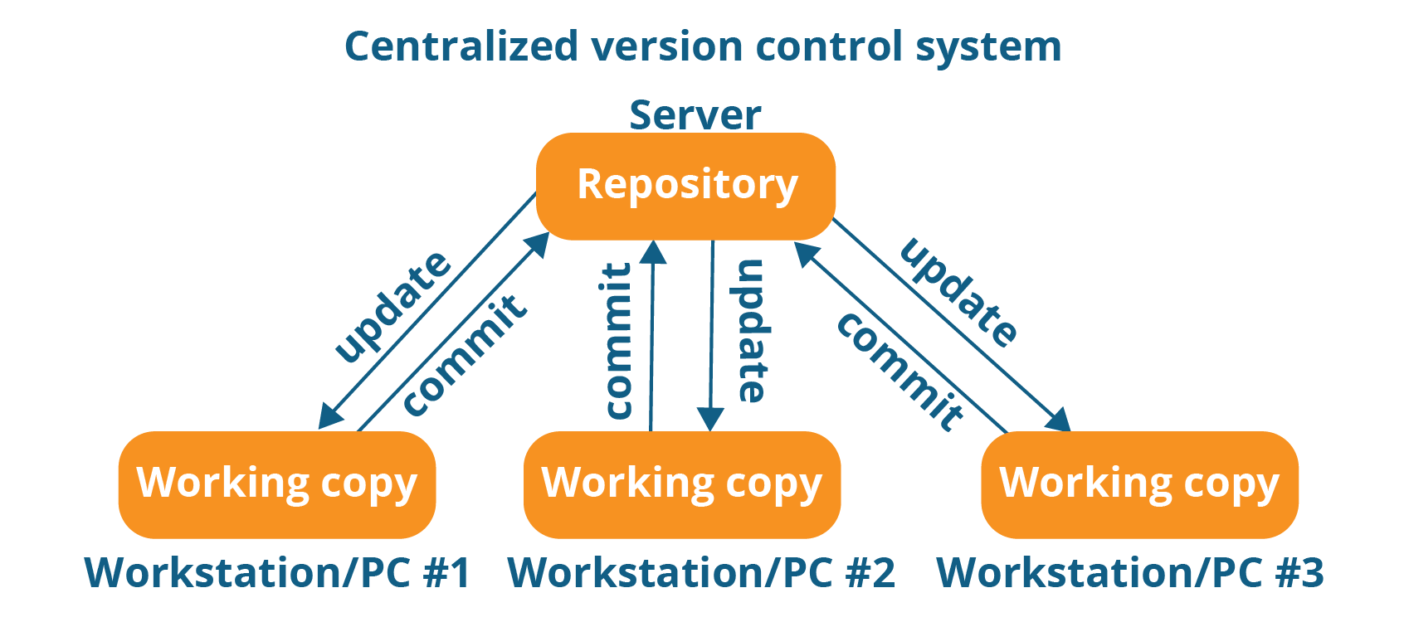

**Decentralized Version Control System**

* Every contributor has a local copy or “clone” of the main repository i.e. everyone maintains a local repository of their own which contains all the files and metadata present in the main repository.

